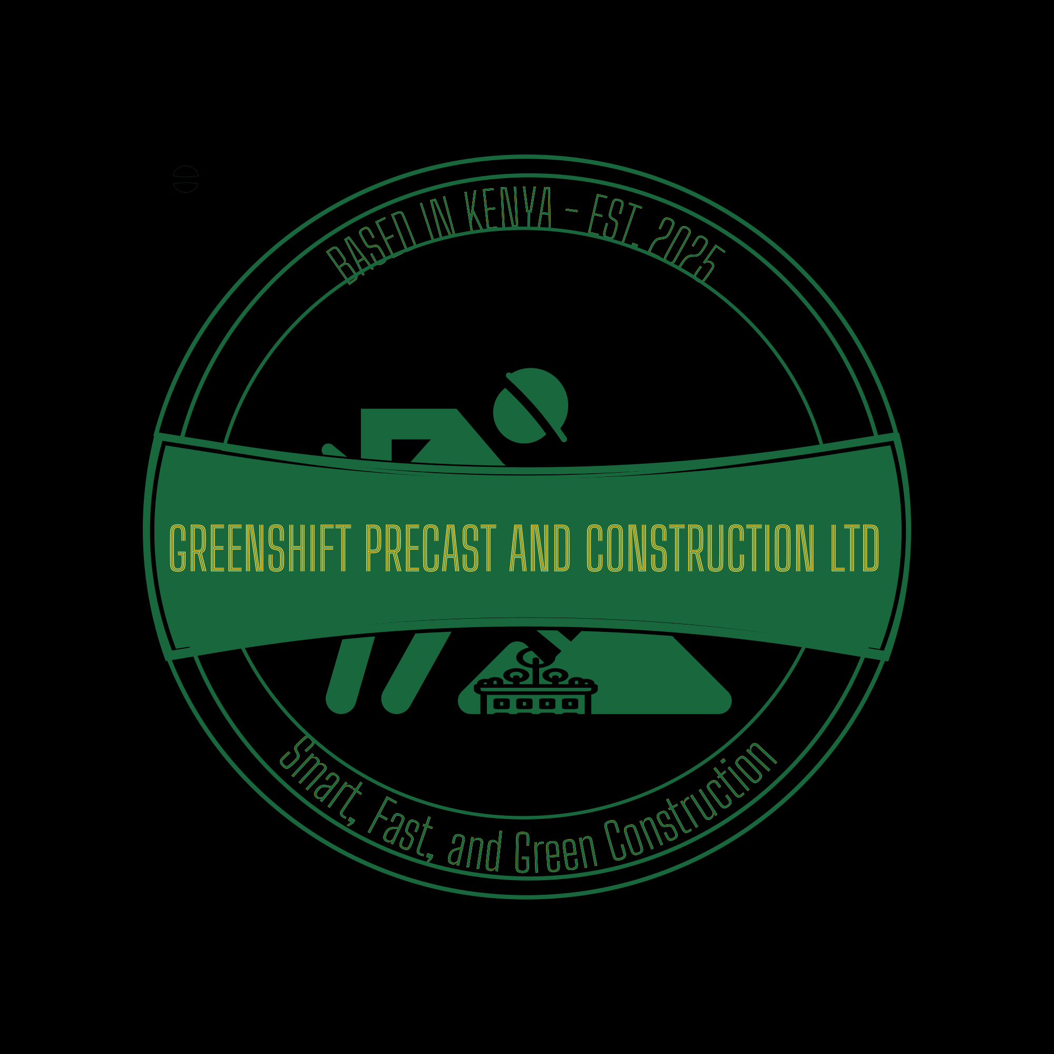

Greenshift Precast and Construction Ltd
Smart, Fast, and Green Construction
Kiambu, Kenya
Phone: [+254796681368] | Email: [kamaugerishon05@gmail.com] | Address: [P.O BOX ]

Company Overview
Greenshift Precast and Construction Ltd is a professional contracting company based in Kenya, focused on delivering modern, affordable, and sustainable construction solutions using precast technology. We aim to redefine Kenya’s construction landscape by offering quick, durable, and eco-friendly building methods for homeowners and developers alike.

Vision Statement
To be Kenya’s leading provider of smart, sustainable, and efficient precast construction solutions.

Mission Statement
To deliver high-quality, environmentally responsible, and cost-effective construction services through innovation, professionalism, and green technology.

Core Values
• Innovation
• Integrity
• Quality workmanship
• Sustainability
• Client satisfaction
• Efficiency

Services Offered
• Precast house construction
• Landscaping and site works
• Foundation and structural works
• Cabro and paving installations
• Drainage and retaining wall systems
• Renovations and extensions
• Consultancy and project management

Target Market
• Homeowners in Kiambu and Nairobi Metropolitan area
• Small developers
• Housing cooperatives
• Real estate investors seeking affordable solutions

Past Projects and Experience
(Demo Section for Reference)
• Residential precast bungalow – Kinangop
• Landscaping and cabro works – Thika, Kikuyu, Kinangop
• Foundation and structural works – Juja
• Client references available upon request.

Contact Information
Greenshift Precast and Construction Ltd
Phone: [+254796681368 / +254784213410]
Email: [kamaugerishon05@gmali.com]
Website: [www.greenshiftconstruction.com]
Location: Kiambu, Kenya

